**SPEAKING COURSE 1 - SOME SAMPLE TESTS**

**PART 1: SOCIAL INTERACTION (INDIVIDUALLY)**

**PRACTICE 1: Answer the questions**

1. How often do you go shopping?
2. What do you like buying?
3. Do you ever shop at shopping malls? What do people like and dislike about shopping at a mall or a supermarket?
4. Do you like shopping online? What are the advantages and disadvantages of shopping online? Why is it developing so quickly?

**PRACTICE 2: Answer the questions**

1. What festival do you like the most?
2. When and where is it held?
3. What is it like?
4. What is the most impressive thing of the festival?
5. What other festivals could you suggest for foreign visitors to Vietnam?

**PRACTICE 3: Answer the questions**

1. What do you like best about your hometown?
2. How has your hometown changed in the recent years?
3. If you could choose a place to live, where would that be?
4. What could be done to make your hometown a better place?
5. Why do many people like living in a city, but some others prefer living in the countryside?

**PRACTICE 4: Answer the questions**

1. What is your major? Do you plan to get a job in the same area as your major?
2. Do you plan to study the master course after university?
3. Do you want to study abroad? Why?
4. What are the factors to make success at university?

**PRACTICE 5: Answer the questions.**

1. Do you spend much time with your family? Who are you closest to in your family?
2. Do you like to eat out or eat at home?Why?
3. Do you often go out in the evenings? What do you like to do when you go out?
4. What usually makes you happy? Does the weather ever affect how you feel?
5. How often do you go online? What do you use the Internet for?

**PART 2: PAIR DISCUSSION**

**SITUATION 1: Your friend and you are making a plan for your summer holiday to Danang City. Discuss and finalize the means of transport you will take--**

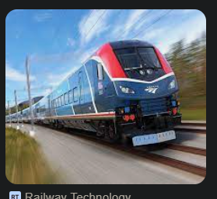 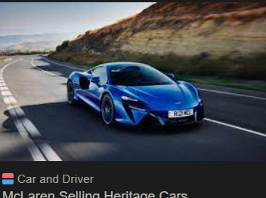

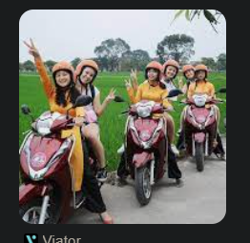 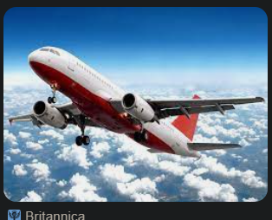

**SITUATION 2: A friend of yours is having a birthday party this weekend. Discuss the following options and decide on the best birthday gift for her**

 

 

SITUATION 3:

**YOU and your friend is planning the year-end party for the whole class. Discuss the following options and decide on the best place for the party**

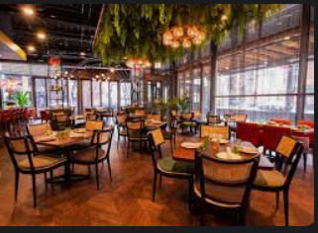 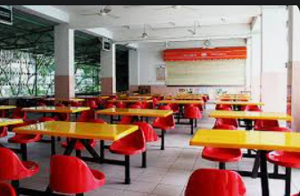

**RESTAURANT SCHOOL CANTEEN**

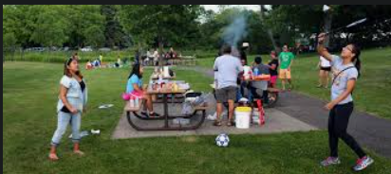 

**IN THE PARK AT SOMEONE’S HOUSE**

SITUATION 4: YOU AND YOUR FRIEND HAVE A DAY OFF AND YOU WANT TO DO SOME ENTERTAINING. Discuss the following options and decide on the best ACTIVITY TO DO

 

**GO TO THE MOVIE HAVE A PICNIC**

 

**STAY AT HOME AND WATCH TV CLEAN UP THE COMMUNITY**